Exploratory Data Analysis (EDA) Report: Credit Card using fraud Detection

Exploratory Data Analysis (EDA) is a crucial step in understanding transaction data, identifying fraudulent behaviour patterns, and generating insights that support fraud detection systems. In this project, we perform EDA on the credit_card_fraud_10k.csv dataset to explore transaction characteristics, detect anomalies, and understand relationships between transaction features and fraud occurrence

Procedure Exploratory Data Analysis:
1.Understand the Problem and the Data
2.Import and Inspect the Data
3.Handling Missing Values
4.Explore Data Characteristics
5.Perform Data Transformation
6.Visualize Data Relationships
7.Handling Outliers
8. Communicate Findings and Insights

Dataset: credit_card_fraud_10k.csv from Kaggle
project Structure:

1.Understand the Problem and the Data
The objective of this project is to analyse credit card transaction data and identify patterns that distinguish fraudulent transactions from legitimate ones. Fraud detection is a critical task in financial systems to prevent monetary losses and enhance customer security.
- Numerical: Transaction Amount,Transaction Hour,Account Age,Transaction Velocity,Daily
Transaction Count.
- Categorical: Foreign Transaction,Online Transaction,Chip Used,High-Risk Merchant
- Target Variable: is_fraud (0 – Non-Fraud, 1 – Fraud)

2.Import and Inspect the Data
File Name: mapping.py / visualization.py
The dataset was loaded into a Pandas DataFrame using the read_csv() function. Initial inspection was performed using:
head() to display the first five records
info() to examine column names, data types, and non-null counts
shape to identify the total number of rows and columns
This step helped in understanding the structure of the dataset and identifying potential issues such as missing values or incorrect data types

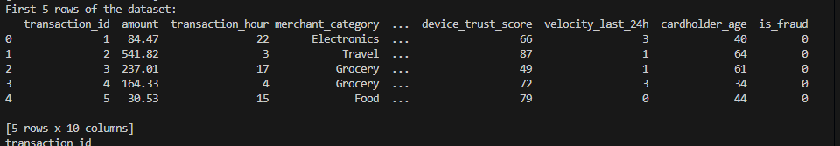

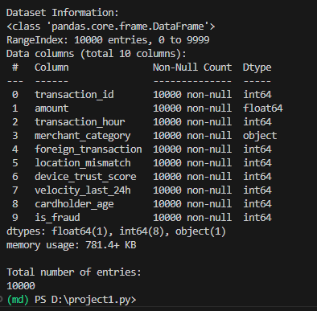
3. Handling Missing Values and Outliers
File Name:
  - Detection of Missing Values
The dataset was checked for missing values using isnull().sum().It was observed that most columns contained no missing values, indicating good data quality.
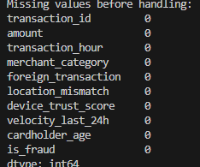
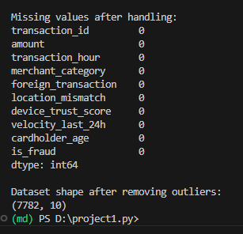

3.2 Mean Imputation:
Any minor missing values in numerical columns were handled using mean imputation to maintain dataset size and preserve transaction distribution.

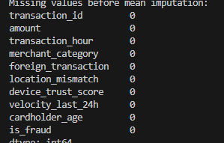

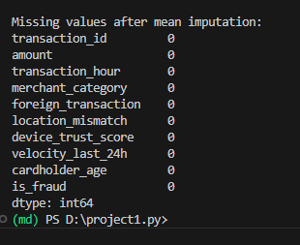

3.3 Duplicate Removal:
Duplicate records were checked using drop_duplicates()
No significant duplicate transactions were found, confirming the integrity of the dataset.
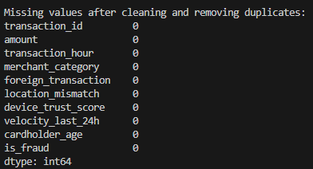

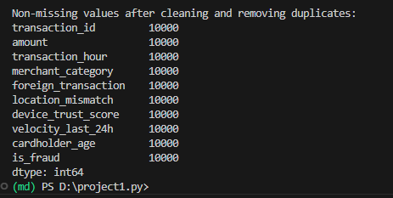

4. Explore Data Characteristics:
File Name:
Using descriptive statistics, we calculated the following for all numeric features
- Mean – Average value of the dataset
- Median – Middle value when data is arranged in order
- Mode – Most frequently occurring value
- Standard Deviation – Measure of how spread out the values
- Minimum – Smallest value in the dataset
- Maximum – Largest value in the dataset
Descriptive statistics were computed using describe() to understand the range, central tendency, and dispersion of numerical features.
Key Observations:
Transaction Amount showed right-skewed distribution,Majority of transactions involved small monetary values,Transaction Hour indicated higher activity during certain hours,Fraud transactions were significantly fewer compared to non-fraud transactions, indicating class imbalance.

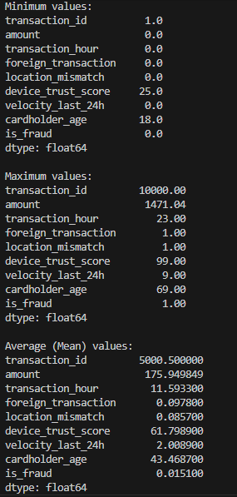

5. Visualize Data Relationships
File Name:
Univariate Analysis
This analysis focuses on one variable at a time to understand its distribution and individual behavior.
Charts:
Histogram: Transaction_id,Frequency
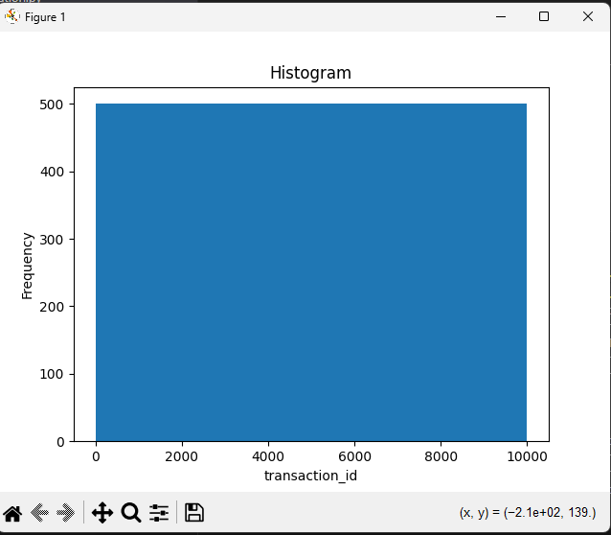

Line Plot: Transaction id,Index
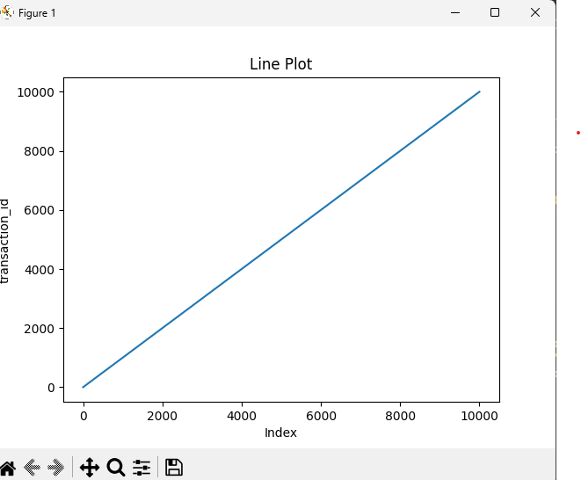

Bar Chart: Transaction_id,counts
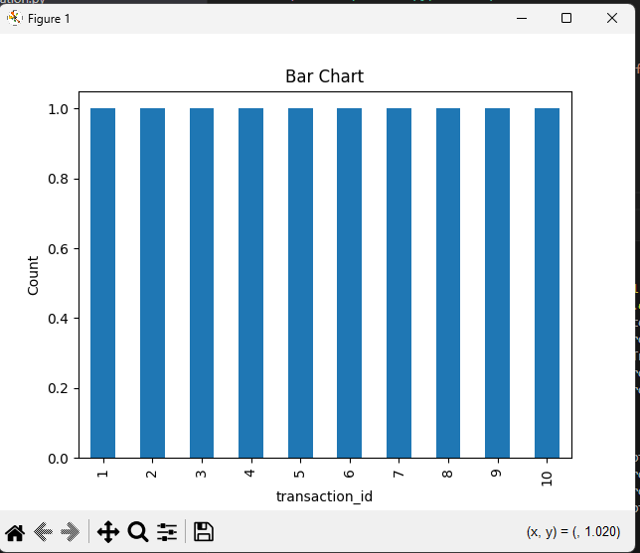
6.Multivariate Analysis:
Multivariate Analysis studies how multiple transaction features together help identify fraud in the credit card datast.
Pair Plot:
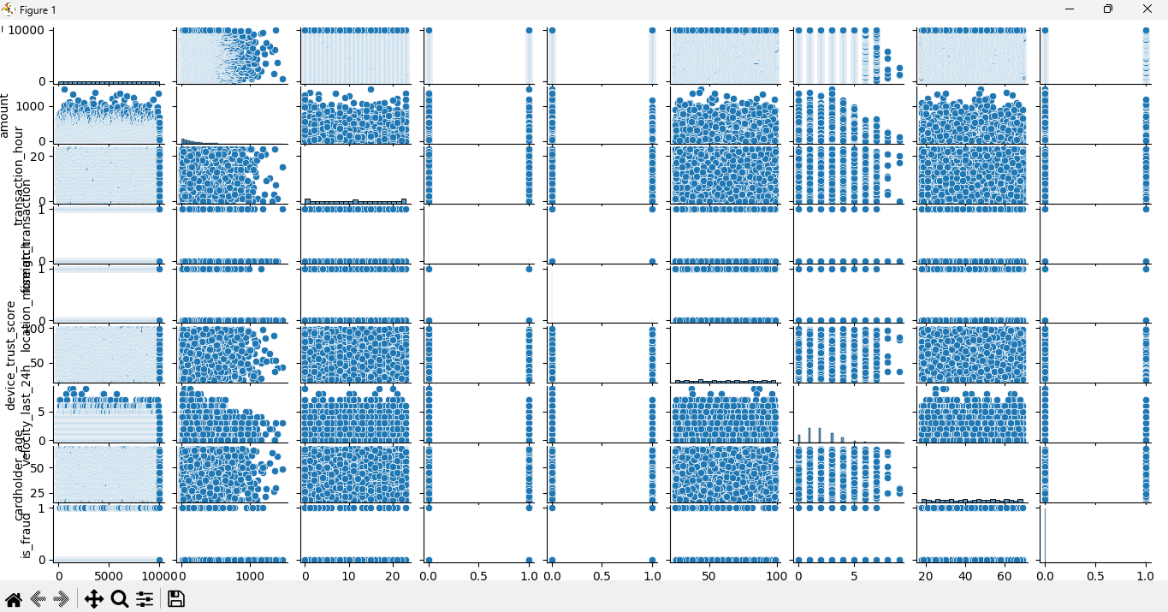

Correlation Heatmap:
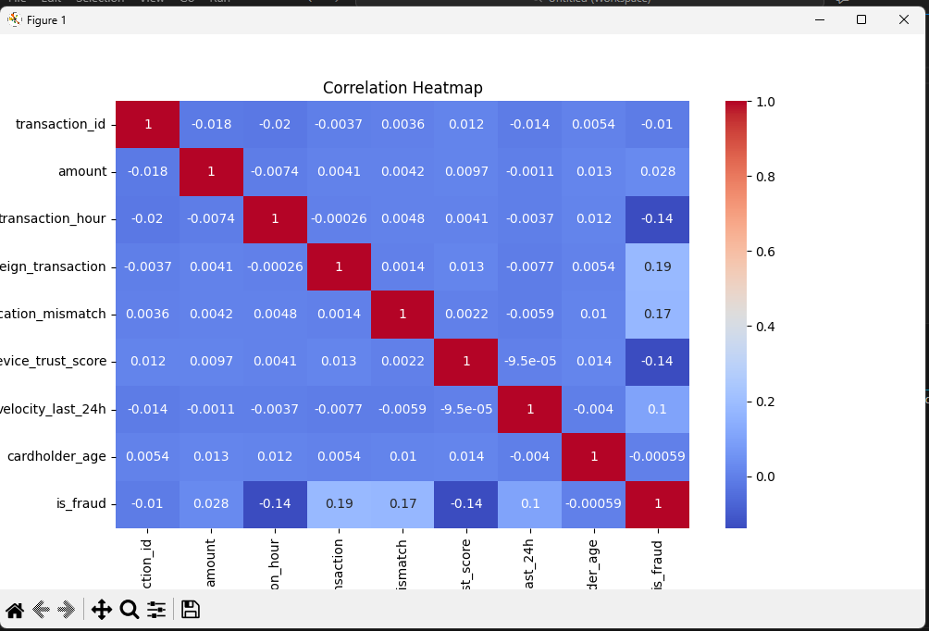
Covariance Heatmap:
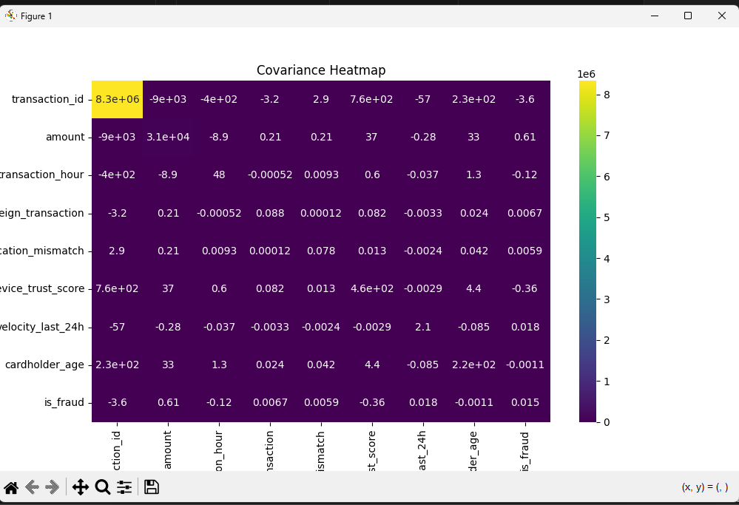
7. Handling Outliers
File Name:
Outliers were detected using the Interquartile Range (IQR) method.
Findings:
Transaction Amount contained extreme values representing unusually large transactions
These outliers were either capped or removed to avoid skewed analysis
This step improved data consistency and visualization clarity.

Logic:
Calculate Q1(25th percentile) and Q3(75th percentile).
Define bounds: Lower = Q1 - 1.5 *IQR; Upper = Q3 + 1.5*IQR
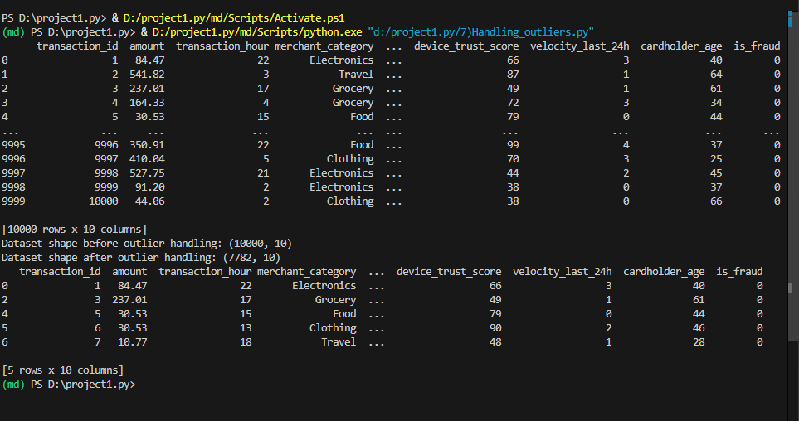
8.Communicate Findings and Insights
File Name:
Key Insights:
Fraud transactions are rare but highly impactful
Foreign transactions show higher fraud probability
High-risk merchants are strongly associated with fraud cases
Transaction timing and velocity play a crucial role in detecting fraud
Dataset is highly imbalanced, requiring special handling during modelling
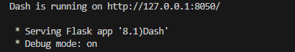

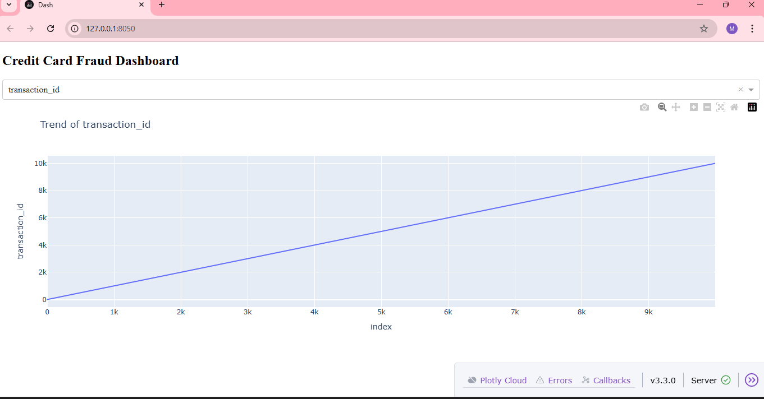

8.Probability Analysis:
Range and variance were calculated for key numeric variables to understand their spread and variability, and histograms with KDE curves were plotted to observe probability distributions.
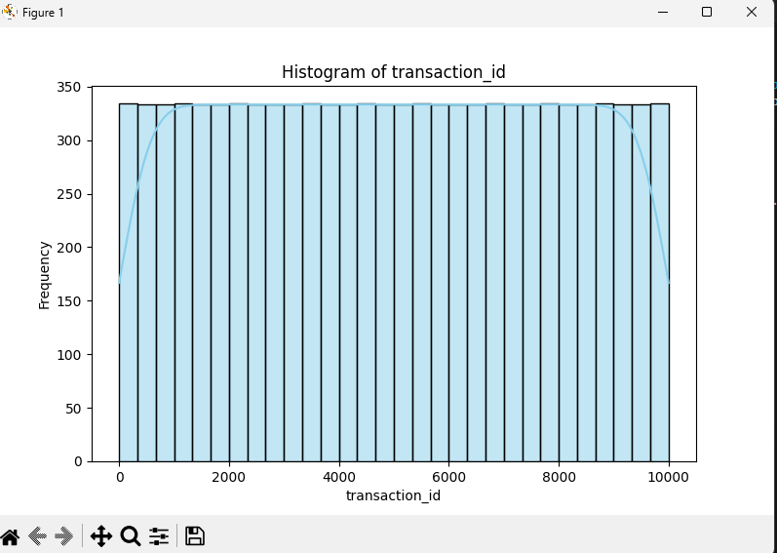

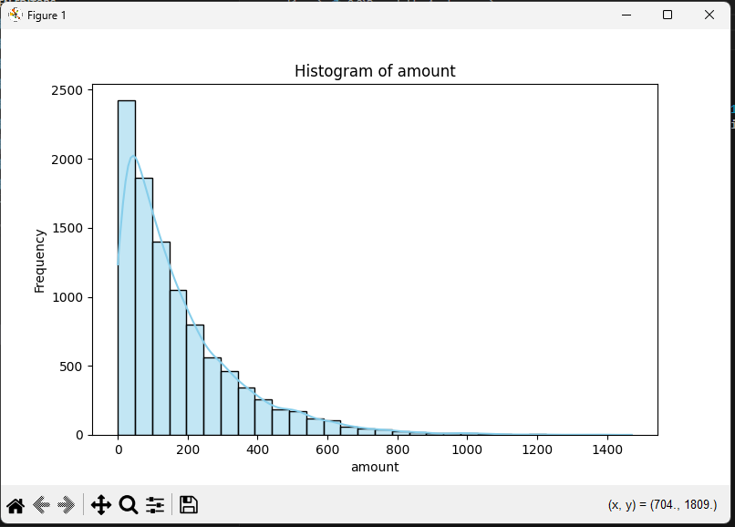

9.K-Means Clustering:
The standardized numeric dataset was clustered into three segments using the K-Means algorithm.

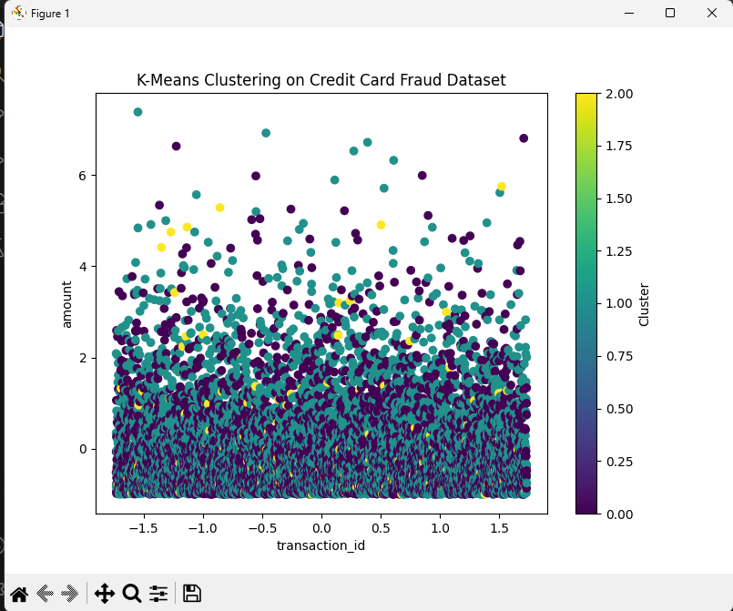
  - Cluster Visualization:
A scatter plot and pair plot were generated to visually distinguish clusters and observe inter- feature relationships.
Scatter plot - Bivariate Analysis:
This analysis examines the relationship between two variables simultaneously.
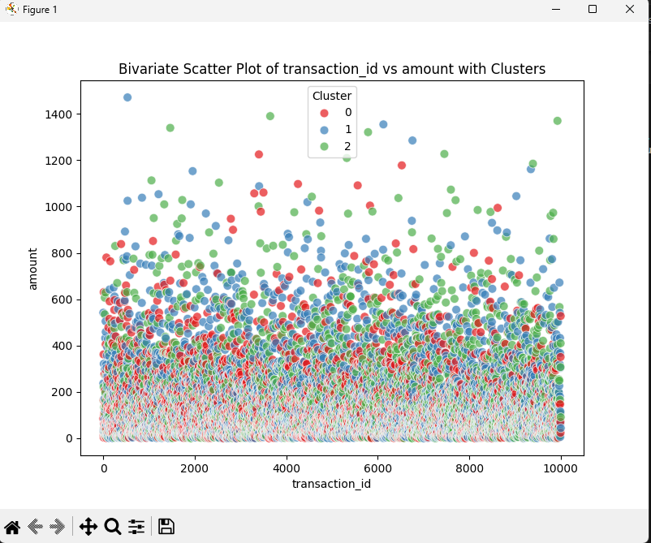

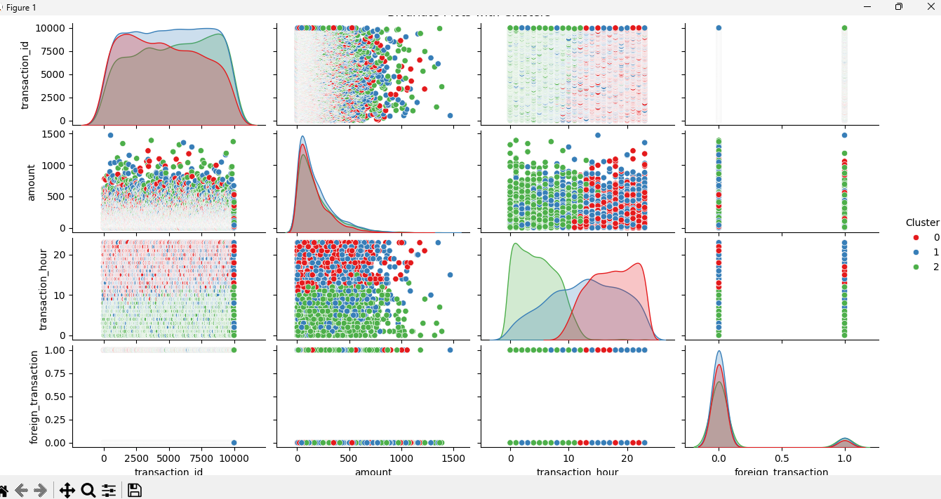
KMeans Pairplot

10. Conclusion:
This project successfully performed an end-to-end Exploratory Data Analysis on the Credit Card Fraud dataset. The data was inspected, cleaned, transformed, and visualized to uncover meaningful patterns related to fraudulent behavior. EDA revealed strong indicators such as foreign transactions, transaction amount, and velocity that contribute to fraud detection. These insights provide a strong foundation for building predictive models and real-time fraud monitoring systems.

